**Amplex Protocol**  
  
**Preparation of an acetylcholine standard curve:**

1. **Prepare 100mM acetylcholine stock solution**  
   -Dissolve 5mg of acetylcholine chloride(Component G) in 275uL of dH20

-Remaining solid should be stored desiccated at -20C

1. **Dilute 100mM acetylcholine stock solution into Reaction Buffer (lysis buffer) to make varying 0-100uM concentrations**

-Use 0uM as a negative control; there should be a 2-fold pattern in this range

-0 to 3.125 to 6.25 to 12.5 to 25 to 50 to 100uM

-A total volume of 100uL

-The acetylcholine concentrations will be twofold lower in the final reaction volume

-Remaining 100uL is Amplex Reagent

|  |  |  |  |  |  |
| --- | --- | --- | --- | --- | --- |
| Concentration of acetylcholine soln(uM) | Volume of ach soln (uL)  1x | Volume of Reaction Buffer (uL) 1x | Total Volume(uL) | Volume of ach soln (uL) 5x | Volume of Reaction Buffer (uL) 5x |
| 0 | 0 | 100 | 100 | 0 | 500 |
| 3.125 | 3.125 | 96.875 | 100 | 15.625 | 484.375 |
| 6.25 | 6.25 | 93.75 | 100 | 31.25 | 468.75 |
| 12.5 | 12.5 | 87.5 | 100 | 62.5 | 437.5 |
| 25 | 25 | 75 | 100 | 125 | 375 |
| 50 | 50 | 50 | 100 | 250 | 250 |
| 100 | 100 | 0 | 100 | 500 | 0 |
| Total | 196.875 | 503.125 |  | 984.375 | 2,515.625 |
| 5x | 984.375 | 2,515.625 |

**Preparation of Amplex Reagent**

1. **Prepare 20mM stock solution of the Amplex Red reagent**

-Allow Component A (one vial) and B to warm to room temperature

-Just prior to use, dissolve contents of Component A with 200uL of Component B

-Should be sufficient for 100 assays of 200uL each

-Remaining Stock Solution should be protected from light in -20C

1. **If needed prepare 25mL of lysis buffer+PPI**

**-**This will be sufficient for a 100 assay experiment

**-**Take 3mL of 10x lysis buffer, 27mL of dH20 and 3 Pierce Phosphatase and Protease Inhibitor Tablets and mix for a total volume of 30mL of lysis buffer + PPI

1. **Prepare a 200U/mL stock solution of horseradish peroxidase (HRP)**

-Take a vial of Component C and dissolve the contents with 1mL of 1X lysis buffer +PPI  
-Separate into aliquots and store in -20C

1. **Prepare a 20U/mL stock solution of choline oxidase**

-Dissolve contents of Component F in 600uL of 1x lysis buffer+PPI

-Separate into aliquots and store in -20C

1. **Prepare 100U/mL acetylcholinesterase (AchE) stock solution**

-Dissolve contents of Component H in 600uL of 1x lysis buffer +PPI

-Separate into aliquots and store in -20C

1. **Prepare working solution of 400uM Amplex Reagent**

-Add 200uL of Amplex Red stock, 100uL of HRP stock, 100uL of choline oxidase stock, 100uL of AchE stock to 9.5mL of lysis buffer+PPI

-This 10mL solution is sufficient for 100 assays

**Plate Layout**

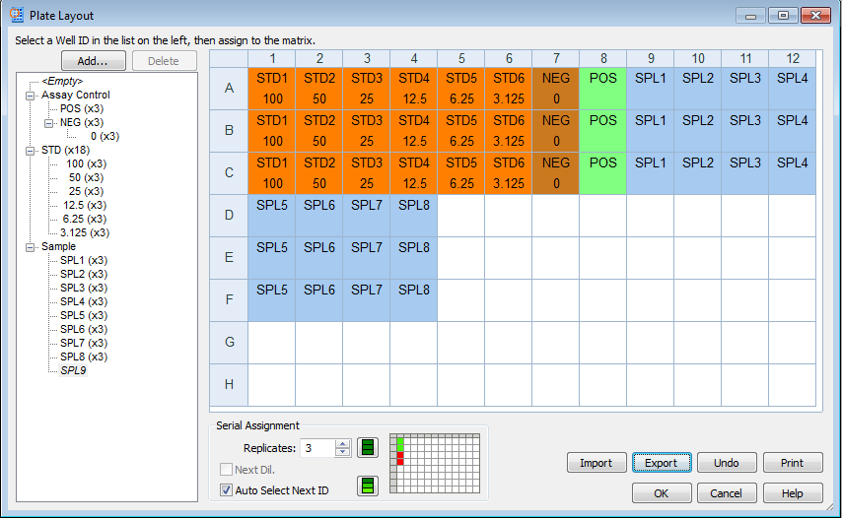

**Confirmation of Standard Correlation**

1. **Making 200uL well solutions**

-Add 100uL of Ach solution of varying concentration as shown on plate layout

-Add 100uL of working Amplex solution into standard wells

1. **Check for correlation**

**-**Run the kinetics for 15 minutes and plot the florescence readings with concentration

**-**Check for robust correlation

**Dilution of Lysates and Plate Recording**

1. **Dilute Sample Lysates with Lysis Buffer + PPI**-Add 10uL of lysate and 90uL of Lysis buffer +PPI into each well column as depicted in plate layout

**-**Add 100uL of working Amplex Reagent

1. **Incubate the reactions for 30 min in plate reader**

-After inserting the plate, run the protocol established on Gen5.

-Protocol should be calibrated such that it will record for 90 minutes at 10 second intervals

-Excitation range should be at 530-560nm and emission should be around 590nm

-First thirty minutes is incubation recordings

-Correct for background fluorescence by subtracting recording with negative control (0uM Ach)

**Preparation of AchE Standard Curve**

1. **Make varying concentrations of AchE solution**

**-**Following the table, make varying concentrations of AchE solution

**-**Use 0uM AchE as negative control

1. **Prepare AchE Amplex solution**

-Add 200uL Amplex stock, 100uL of HRP stock, 100uL of choline oxidase stock, and 10uL of Ach stock to 9.59mL of 1x lysis buffer +PPI

1. Load the Wells

-Following the Plate Layout, add 100uL of diluted AchE solution and 100uL of working AchE Amplex solution to wells

**Follow same steps for AchE activity as done for Ach activity**